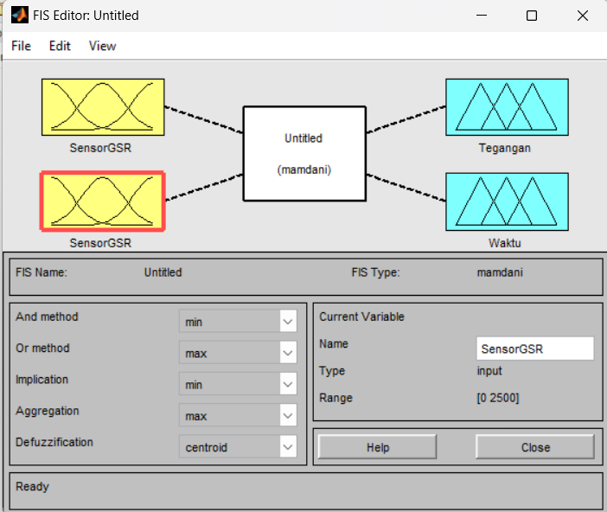

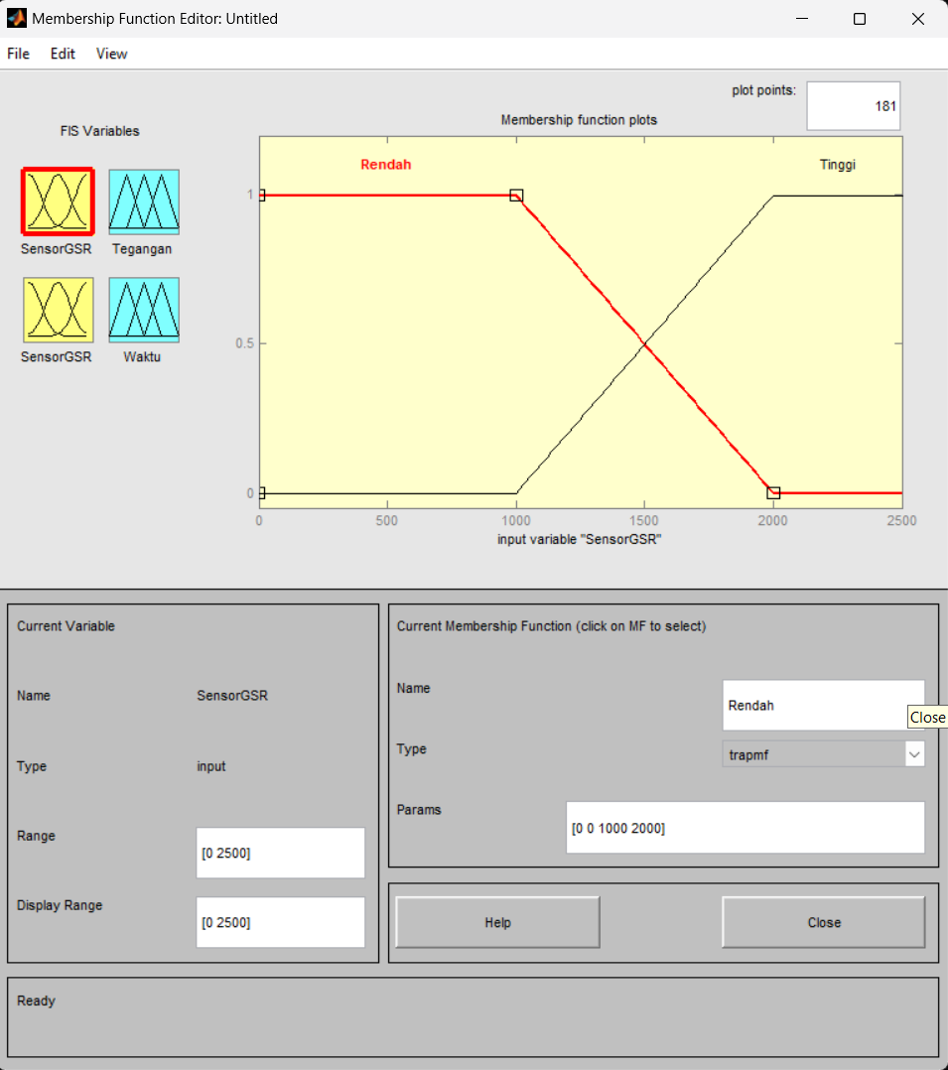

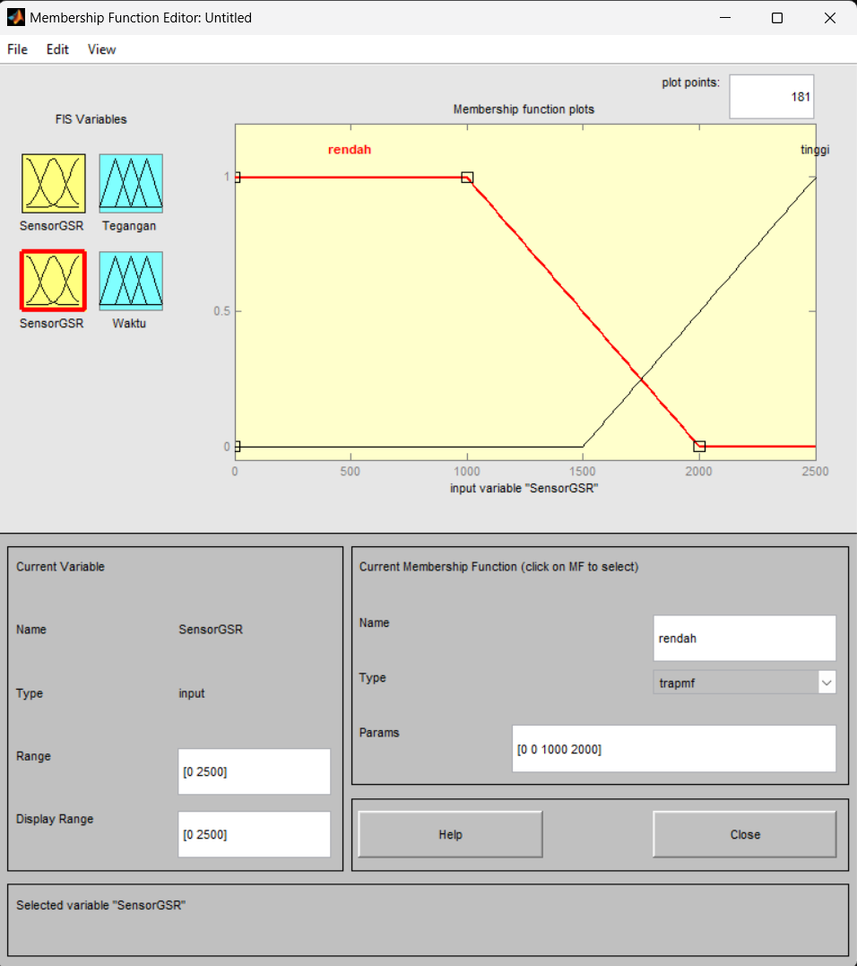

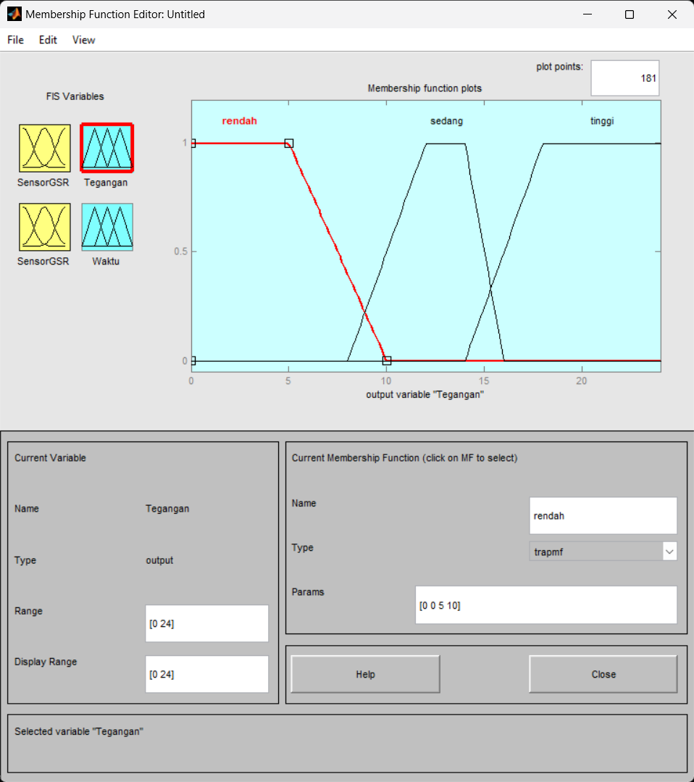

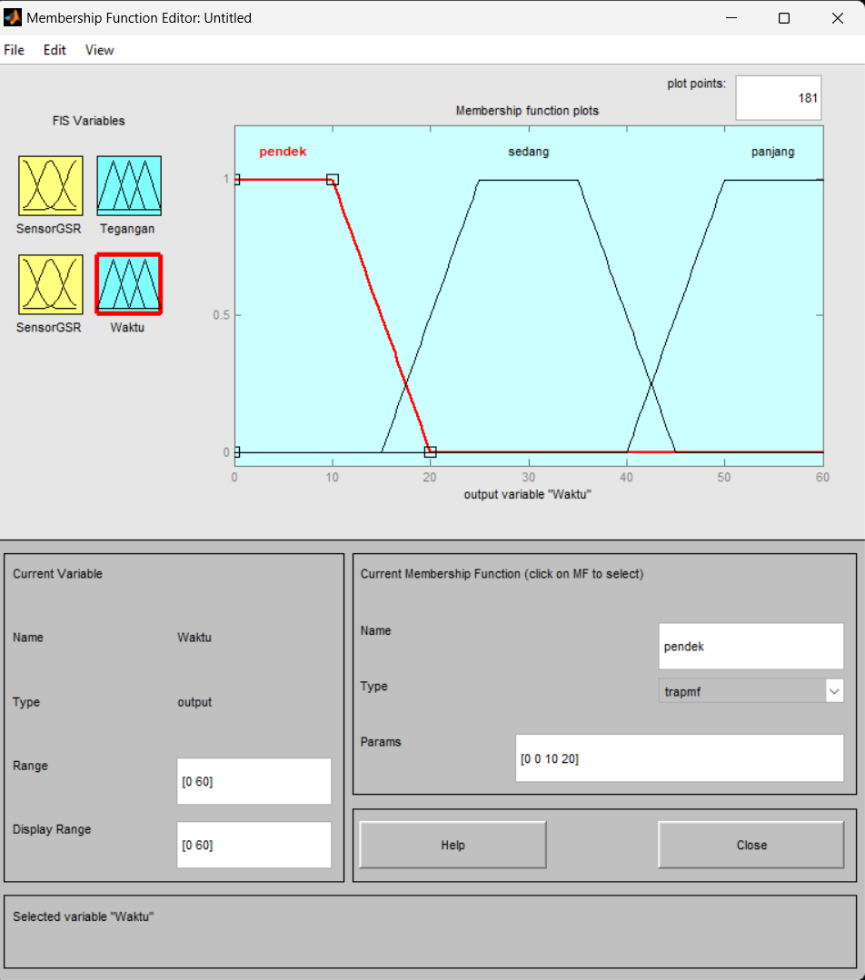

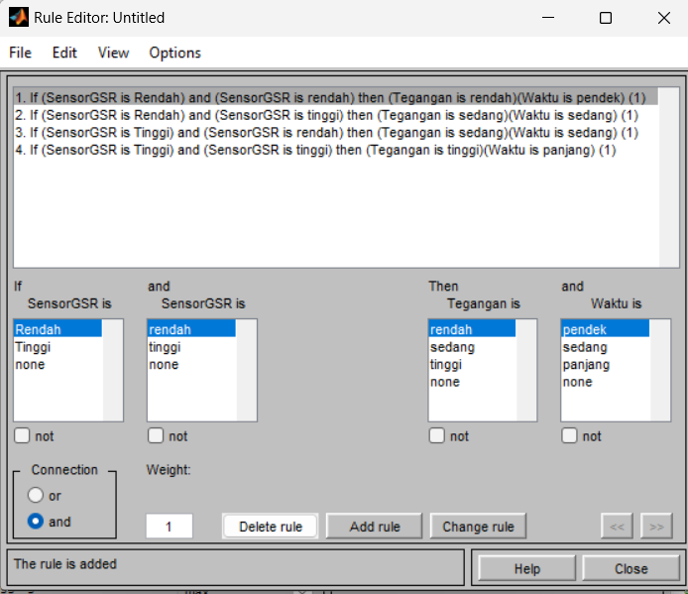

Rule 1: IF (SensorGSR1 is Rendah) AND (SensorGSR2 is Rendah)

THEN (Tegangan is Rendah) AND (Waktu is Pendek)

Rule 2: IF (SensorGSR1 is Rendah) AND (SensorGSR2 is Tinggi)

THEN (Tegangan is Sedang) AND (Waktu is Sedang)

Rule 3: IF (SensorGSR1 is Tinggi) AND (SensorGSR2 is Rendah)

THEN (Tegangan is Sedang) AND (Waktu is Sedang)

Rule 4: IF (SensorGSR1 is Tinggi) AND (SensorGSR2 is Tinggi)

THEN (Tegangan is Tinggi) AND (Waktu is Panjang)

